**ABSTRACT**

Smart Waste Management system which is proposed here is to implement a smarter way of conventional waste management using smart sensors to gather fill-level data, presence of garbage around the dustbin and stinking condition from containers and garbage bins, and send it to servers in real time. An authorized phone number which are present in Waste Management Centres gather fill-level and other information sent from multiple containers which are situated throughout a city/locality. The data acquired as above, can be used to systematically plan route-map to collect garbage. The information from bins to the authorized number is sent using communicating modules (GSM/GPRS module). The entire operation is controlled using Atmega328P 8-bit microcontroller. This report showcases a potential design for an IoT gateway that can be used to provide a framework for a smart waste management system.

**INTRODUCTION**

The Internet of Things (IoT)refers to things that are connected to the internet and can often be managed from there. Garbage is described as solid substances generated as a result of human activities that are removed from the system because they are no longer useful in the respective economic, biomedical, or technical method. In a wider context, solid waste refers to all products that are used in the home, industry, or agriculture. Municipal solid waste (MSM) is described as waste that accrues in areas maintained by municipalities that are responsible for its disposal and recycling. People can throw garbage in waste bins, which is why they are valuable in life. If it didn't happen, the future would be a mess. Because a business or household has a garbage disposal device, it becomes a valuable piece of equipment. The dustbin's position as a conciliator of changing waste practices has barely been regarded, despite its importance in our daily lives. Bins, it is believed, are providing a telling indicator of new garbage relationships in society as they are repurposed as environmental technologies for modern recycling schemes.

**OBJECTIVES**

Our goal is to creat Smart Waste Management system which is proposed here is to implement a smarter way of conventional waste management using smart sensors to gather fill-level data, presence of garbage around the dustbin and stinking condition from containers and garbage bins, and send it to servers in real time. Bins, it is believed, are providing a telling indicator of new garbage relationships in society as they are repurposed as environmental technologies for modern recycling schemes.

**PROBLEM FORMULATION**

The city diverts about 80% of its waste from landfills and hopes to go “zero waste” by the end of 2020. Besides strict regulations and high waste management fees for end consumers and businesses, San Francisco has added technology to its recycling and composting operations. First, the city partnered with Recology, a company that spent $20 million to revamp its materials recovery facilities (MRFs). Recology leverages optical sorters, robots, and a machine vision system to evaluate the sorting equipment's effectiveness and recover plastic that would otherwise get lost. San Francisco went on to install Nordsense garbage level sensors in trash bins along major commercial corridors. The solution helped municipal authorities  reduce the number of overflowing containers by 80%  while optimizing operational expenses.

**LIST OF COMPONENTS**

|  |  |  |
| --- | --- | --- |
| **S.No** | **Components** | **Quantity** |
| 1 | Load Cell | 1 |
| 2 | Ultrasonic Sensor | 1 |
| 3 | Voice System | 1 |
| 4 | ESP 8266 | 1 |
| 5 | P10 Display | 1 |

**LOAD CELL**

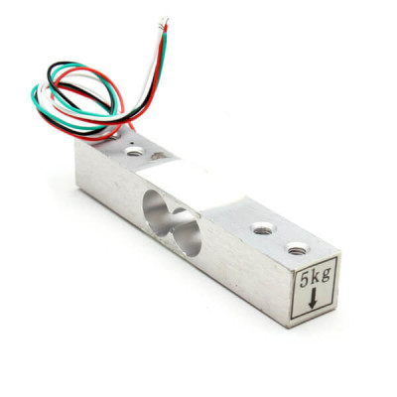

Load cells are sensors that detect force (mass, torque, etc.). When force is applied to a load cell, it converts the force into an electrical signal. Load cells are also known as "load transducers," because they convert a load (force) into electrical signals.

**ULTRASONIC SENSOR**

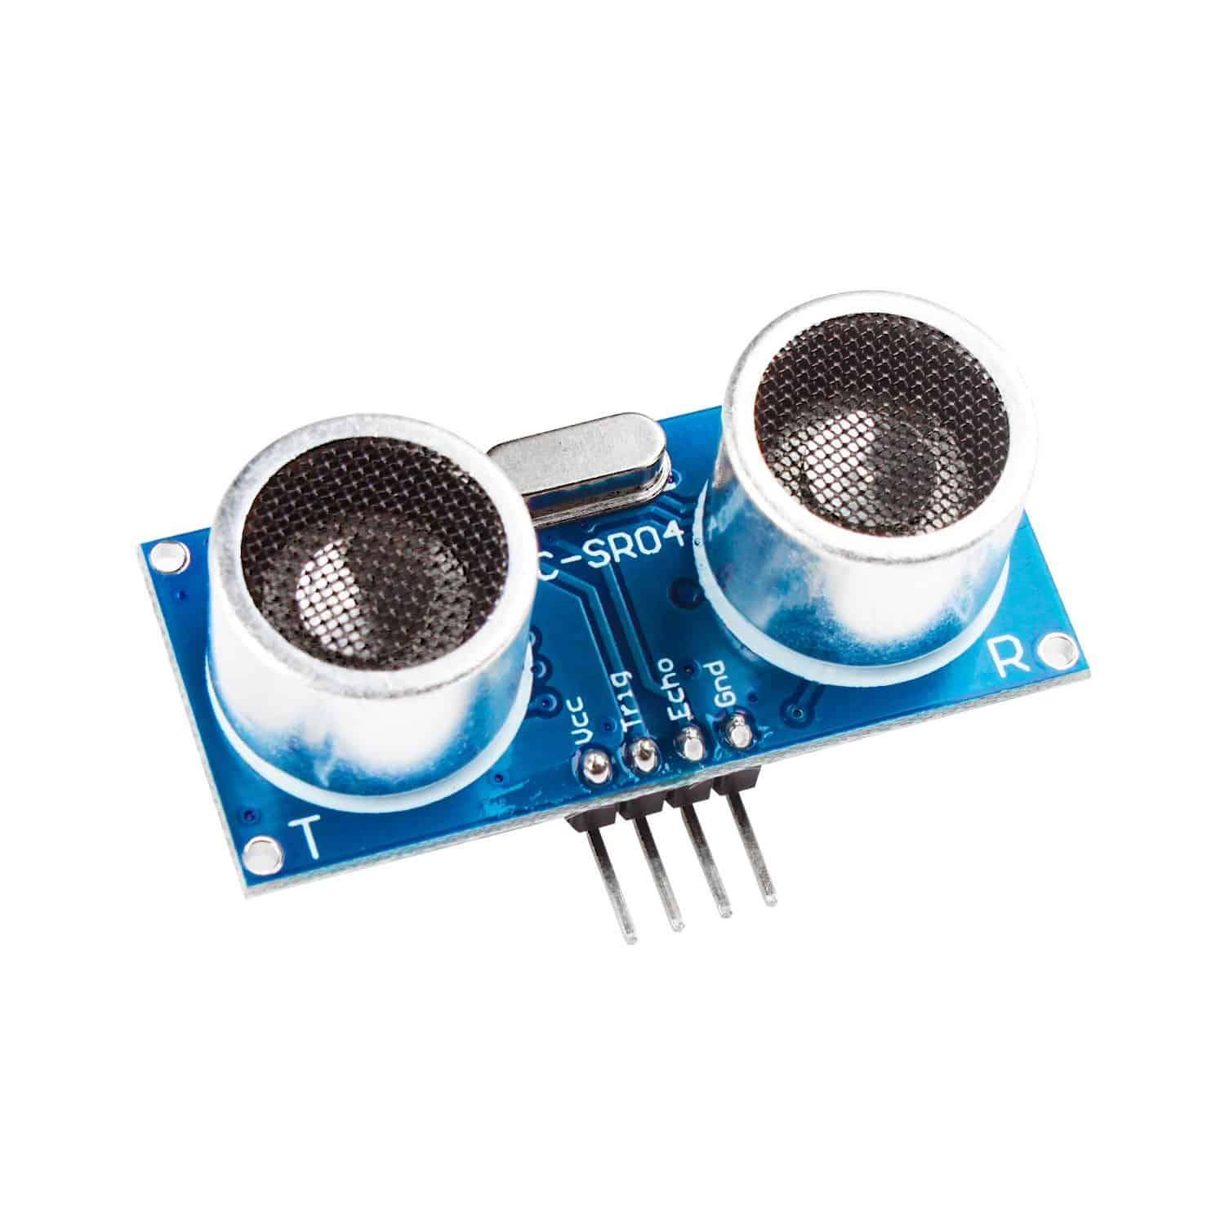

Ultrasonic sensors can detect the movement of targets and measure the distance to them in many automated factories and process plants. Sensors can have an on or off digital output for detecting the movement of objects, or an analog output proportional to distance.

**VOICE SYSTEM**



Voice computing is the discipline that develops hardware or software to process voice inputs.It spans many other fields including human-computer interaction, conversational computing, linguistics, natural language processing, automatic speech recognition, speech synthesis, audio engineering, digital signal processing, cloud computing, data science, ethics, law, and information security.

**ESP 8266**

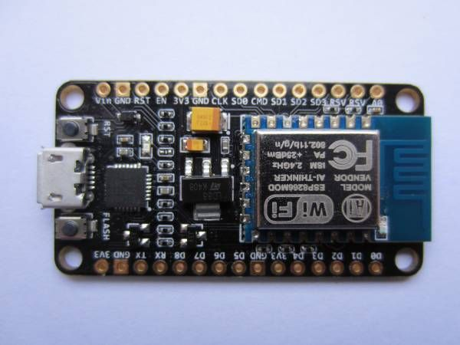

The ESP8266 is a low-cost Wi-Fi microchip, with built-in TCP/IP networking software, and microcontroller capability. This small module allows microcontrollers to connect to a Wi-Fi network and make simple TCP/IP connections using Hayes-style commands. However, at first, there was almost no English-language documentation on the chip and the commands it accepted.The very low price and the fact that there were very few external components on the module, which suggested that it could eventually be very inexpensive in volume, attracted many hackers to explore the module, the chip, and the software on it, as well as to translate the documentation.

**P10 DISPLAY**

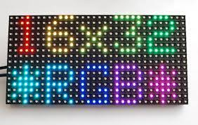

A LED display is a flat panel display that uses an array of light-emitting diodes as pixels for a video display. Their brightness allows them to be used outdoors where they are visible in the sun for store signs and billboards. In recent years, they have also become commonly used in destination signs on public transport vehicles, as well as variable-message signs on highways. LED displays are capable of providing general illumination in addition to visual display, as when used for stage lighting or other decorative purposes. LED displays can offer higher contrast ratios than a projector and are thus an alternative to traditional projection screens, and they can be used for large, uninterrupted video walls. Micro LED displays are LED displays with smaller LEDs, which poses significant development challenges.

**PROPOSED METHOD**

In this proposed smart waste management system for metropolitan cities for each separate bins we use GPS tracker to keep track of location and using load cell we can see wheather the bins are fill or not if the bins are fill the municipality van will come and pickup and clean the bins and put the bins in the place.If the bins are fill it will also alert using LED display not to put waste in the same bin.

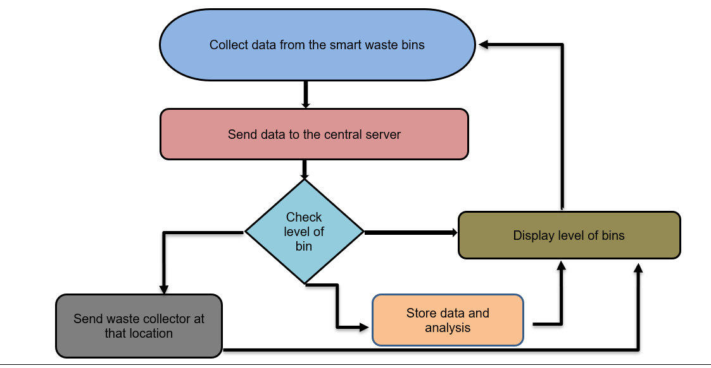

**CIRCUIT DIAGRAM**

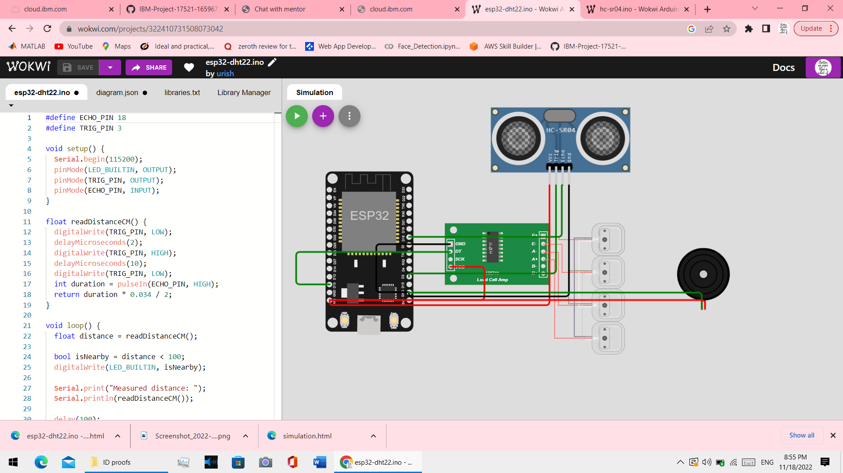

**SOLUTION STATEMENT**

As we know due to COVID 19 there is arising problem of cleaning and garbage maintence .we have a proposed method of what smart waste management to control this problem in big metropolitan cities .

**CONCLUSION**

waste management is faced with a number of issues which include lack of throughput, inadequate solid waste data, efficiency problem, delays in collection and resistance to new technologies. Presently, waste management is a major problem for authorities who are responsible for such task because it’s a costly service and it hugely impacts the environment as a whole. This study introduced a smart waste monitoring system that uses several sensors and communication technologies to achieve the set task. The proposed system was achieved through the development of theoretical models, layout and decision-making algorithms in the course of the project. There is an enormous amount of room for the development of this project in order for it to meet commercial standards.